Problem 2-3.2 Report File

Alex Helfrich

CS 3304 Section 04

For problem 2a an integer n is asked for, and the output of n! given, as well as the nth index of the Fibonacci series. Then a message is asked for, and the number of times that the message is to be repeated. The message is then displayed the given number of times, and it is determined whether or not the message is a palindrome.

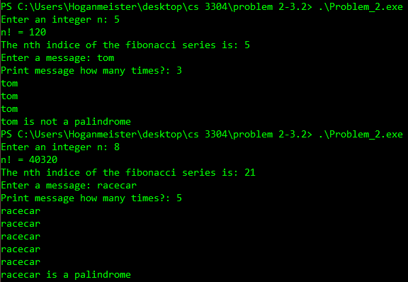

The code to sum the first n integers is also implemented, and looks like:

Int sum(int n) { return n + sum(n-1); }

The original non-recursive function looks like:

for(int i = integerN; i > 0; i--) {

output = output + i; }

The recursive program takes a lot more memory, as it has to reassign every variable each time it is called, whereas the non-recursive program simply adds spaces in memory as it goes, meaning that it would run faster.

3.1

a) Code will run n times, meaning it has a runtime of O(n).

b) The code will run n times for the first loop, and n times for the second loop, meaning that the runtime will be O(n^2).

c) The first loop runs n times, and the second loop runs n^2 times, so the runtime will be O(n^3);

d) The first loop runs n times, and the second loop runs i times, so the runtime will be O(n^2).

e) The first loop runs n times, the second i\*i times, and the third j times. The runtime is O(n^5);

f) The first loop runs n times, the second i times, the third runs i/2 times. The runtime is O(n^2).

3.2

a) O(n^2)

b) O(n^2)

c) O(n)

d) O(n^2)

e) O(n^3)